Design and apply context-aware access controls based on user identity, device posture, location, and application risk.

Group details :-

s.no | name | college | Contact
1. | Sandhiya s | KSG college of arts and science | ss4792520@gmail.com
2. | Rohith G | KSG college of arts and science | rohithrothith1558@gmail.com
3. | Mithiran S | KSG college of arts and science | mithranran441@gmail.com
4. | Matheshwari A | KSG college of arts and science | matheswarideepa@gmail.com

Introduction:-
In today’s rapidly evolving digital world, organizations face increasing cyber threats that can compromise sensitive data and digital assets. Traditional security models that trust users inside a network are no longer effective due to cloud computing, remote work, and personal devices.
This project proposes the development of an AI-driven incident response and context-aware access control system to improve cybersecurity. Instead of relying only on usernames and passwords, the system evaluates multiple factors such as user identity, device security status, location, and application risk before granting access.
By analyzing these contextual signals in real time, the system can allow, restrict, or block access when necessary. This intelligent approach helps organizations reduce cyber risks while maintaining a secure and smooth experience for legitimate users.

ABSTRACT:
The rapid growth of cloud computing, mobile devices, and hybrid work environments has weakened the traditional concept of network boundaries. As employees access organizational resources from multiple devices and locations, conventional access control methods are no longer sufficient to protect sensitive information. Modern systems face increased security risks from compromised devices, insecure networks, and internal threats, making simple allow-or-deny access decisions inadequate.
This project focuses on developing a context-aware access control system that evaluates multiple factors before granting access to digital resources. These factors include user identity, device security condition, geographic location, and the risk level of the requested application. A policy-based engine analyzes these contextual inputs and generates a real-time risk score to determine the appropriate access decision.
Based on the calculated risk level, the system can allow full access, require additional authentication such as multi-factor authentication (MFA), restrict certain actions, or completely block the request. The goal is to create an adaptive security framework that strengthens protection against credential misuse while maintaining a smooth experience for trusted users.
By dynamically adjusting access decisions according to the security context, this approach helps organizations safeguard their data and systems in a highly distributed and evolving digital environment.

Use Case Scenarios

Scenario 1: Finance Department Access to ERP System
A senior accountant needs to access the corporate ERP system to process monthly payroll. The user connects remotely using a company-managed laptop and authenticates through Azure Active Directory with multi-factor authentication (MFA). The system evaluates the user’s identity, group membership, device posture, and connection context before allowing secure access only to the ERP application through a micro-tunnel.

Scenario 2: Contractor Access to Specific Project Repository
An external consultant requires limited access to a specific internal Git repository for a project. The contractor is registered as a guest user and assigned to a designated group. After authentication, the system verifies device security compliance and grants restricted access to the repository during defined business hours, preventing access to other internal resources.

Scenario 3: Executive Access to Sensitive Financial Documents
A company vice president attempts to access confidential financial documents stored in SharePoint while traveling internationally. After authenticating with MFA, the system evaluates the user’s identity, device security status, location, and the sensitivity of the application. Due to the unusual location and high-risk application, additional restrictions are applied to the session.

Scenario 4: Remote Support Technician Access to Internal Tools
An IT support technician connects from a home office using a company-managed system to assist employees. After authentication, the system verifies the technician’s identity, group membership, device compliance, and connection location. Secure access is granted only to the necessary tools such as ServiceNow and the remote desktop jump host.

Scenario 5: High-Risk Application Access from a Low-Trust Location
A marketing coordinator attempts to access the corporate Salesforce system from a public Wi-Fi network using a managed smartphone. After verifying identity and device compliance, the system detects the network as high risk. Access is provided through a secure browser isolation environment to protect sensitive customer data.

Stage-1

Title: Owasp top 10 categories and vulnerabilities

Overview:
As digital technology continues to grow, cyberattacks are becoming more frequent and sophisticated. Organizations must respond to security incidents quickly to protect sensitive information and digital assets. Traditional security models that automatically trust users inside a network are no longer effective in today’s environment.
With the widespread use of cloud services, remote work, and personal devices (BYOD), the concept of a fixed network boundary has largely disappeared. Employees now access organizational resources from different locations and devices, which increases security risks. Because of this shift, modern security systems must evaluate every access request carefully and in real time.
This project proposes an AI-driven incident response and context-aware access control system. The system analyzes several factors before granting access, including user identity and role, device security status, geographic location, and the risk level of the application being accessed. Based on these factors, the system can allow full access, restrict certain features, require multi-factor authentication, or block access completely.
The main objective is to create a dynamic and intelligent security model that reduces cyber risks and protects sensitive data. At the same time, it ensures that trusted employees can access resources smoothly, allowing organizations to maintain both strong security and efficient productivity in a modern digital environment.

S.no | Vulnerabilities | CWE/CVE number
1 | Improper Access Control | 284
2 | Active Debug Code | 489
3 | Reliance on Component That is Not Updateable | 1329
4 | Insufficient Entropy | 331
5 | Improper Input Validation | 20
6 | Interpretation Conflict | 436
7 | Session Fixation | 384
8 | Untrusted Search Path | 426
9 | Insufficient Logging | 778
10 | Divide By Zero | 369

Report
1.Vulnerability Name:- Improper Access Control
CWE/CVE :- CWE-284
OWASP/SANS Category:- A01:2025 Broken Access Control
Description:- The product does not restrict or incorrectly restricts access to a resource from an unauthorized actor.
Business Impact:- Improper access control occurs when users are granted inappropriate or excessive permissions to systems, applications, or data. This security weakness can lead to serious consequences for organizations, affecting confidentiality, integrity, and availability of critical resources.

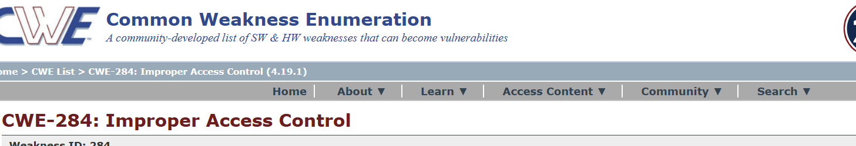
2. Vulnerability Name:- Active Debug Code
CWE/CVE :- CWE-489
OWASP/SANS Category:- A02:2025 Security Misconfiguration
Description:- The product is released with debugging code still enabled or active.
Business Impact:- Active debug code refers to debugging statements, testing functions, or development features that remain enabled in production systems. While these are useful during development and troubleshooting, leaving them active in a live environment can introduce security and operational risks that may affect business performance.

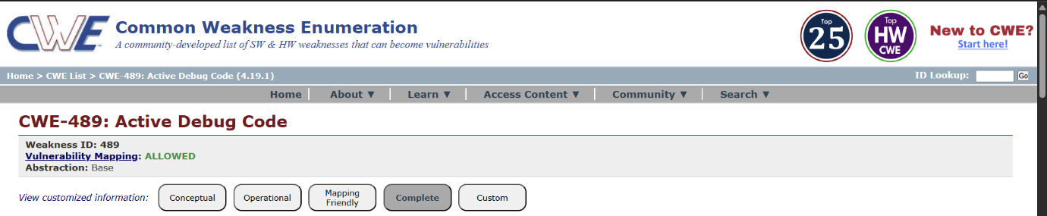

3. Vulnerability Name:- Reliance on Component That is Not Updateable
CWE/CVE :- CWE-1329
OWASP/SANS Category:- A03:2025 Software Supply Chain Failures
Description:- The product contains a component that cannot be updated or patched in order to remove vulnerabilities or significant bugs.
Business Impact:- Reliance on components that cannot be updated refers to the use of software libraries, frameworks, or third-party components that no longer receive updates, patches, or vendor support. These outdated components can introduce security and operational risks that significantly affect an organization’s systems and business operations.

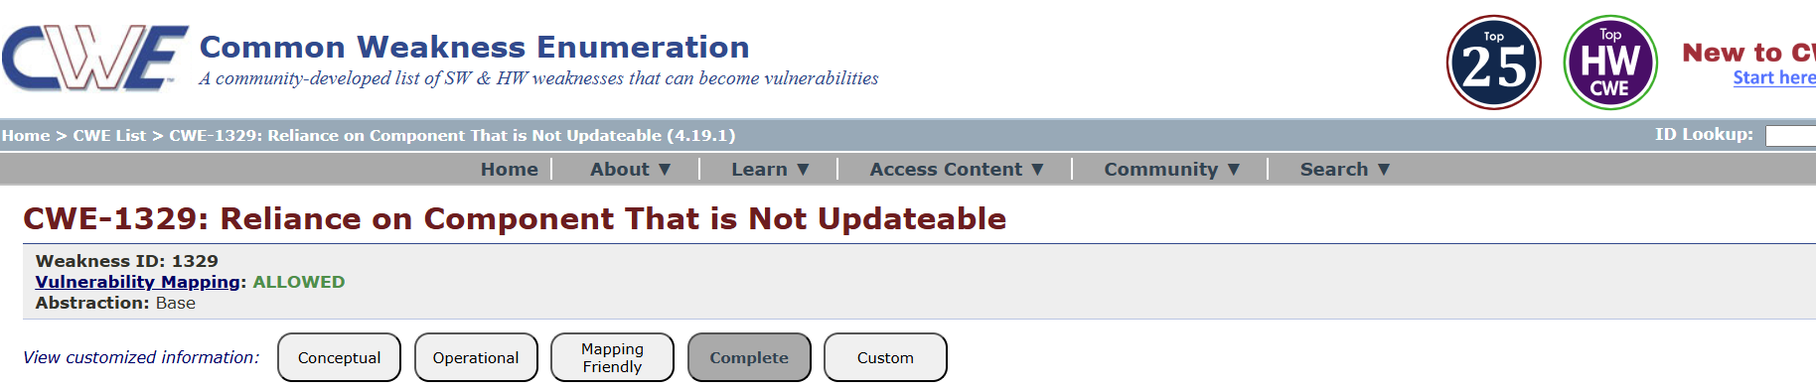

4. Vulnerability Name:- Insufficient Entropy
CWE/CVE :- CWE-331
OWASP/SANS Category:- A04:2025 Cryptographic Failures
Description:- The product uses an algorithm or scheme that produces insufficient entropy, leaving patterns or clusters of values that are more likely to occur than others.
Business Impact:- Insufficient entropy occurs when systems generate weak or predictable random values for security mechanisms such as cryptographic keys, session IDs, or authentication tokens. Weak randomness reduces the effectiveness of security controls and can expose organizations to serious risks.

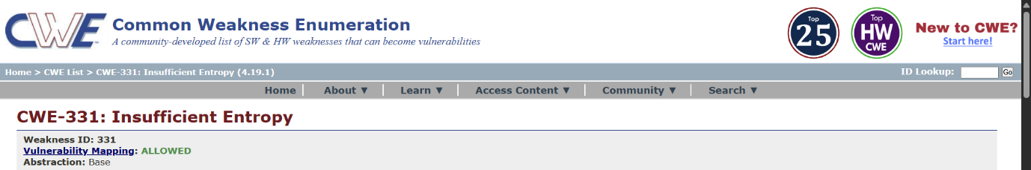

5. Vulnerability Name:- Improper Input Validation
CWE/CVE :- CWE-20
OWASP/SANS Category:- A05:2025 Injection
Description:- The product receives input or data, but it does not validate or incorrectly validates that the input has the properties that are required to process the data safely and correctly.
Business Impact:- Improper input validation occurs when an application fails to properly check and sanitize user inputs before processing them. This vulnerability can allow attackers to submit malicious data that may compromise application security, system functionality, and sensitive information.

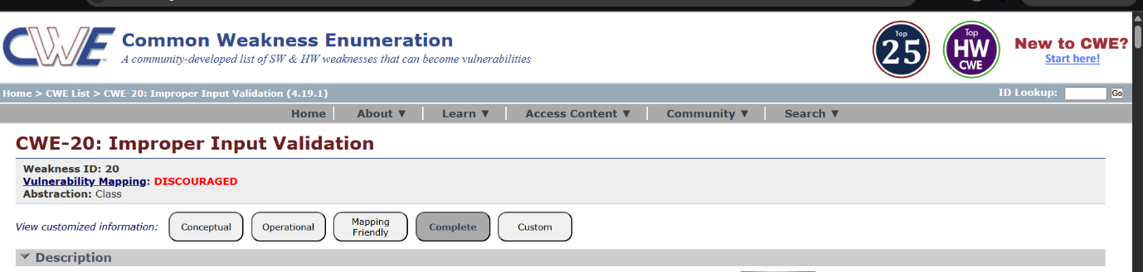

6. Vulnerability Name:- Interpretation Conflict
CWE/CVE :- CWE-436
OWASP/SANS Category:- A06:2025 Insecure Design
Description:- Product A handles inputs or steps differently than Product B, which causes A to perform incorrect actions based on its perception of B's state.
Business Impact:- Interpretation conflict occurs when different components of a system interpret the same input data differently. This inconsistency can lead to security vulnerabilities, incorrect processing of data, and unexpected system behavior, which may affect business operations and security.

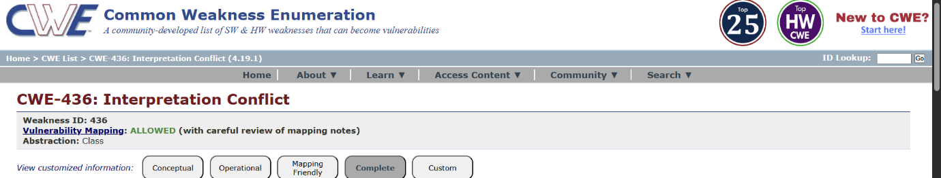

7. Vulnerability Name:- Session Fixation
CWE/CVE :- CWE-384
OWASP/SANS Category:- A07:2025 Authentication Failures
Description:- Authenticating a user, or otherwise establishing a new user session, without invalidating any existing session identifier gives an attacker the opportunity to steal authenticated sessions.
Business Impact:- Session fixation is a security vulnerability in which an attacker forces a user to use a known session ID. After the user logs in, the attacker can reuse the same session ID to gain unauthorized access to the user’s account or system resources.
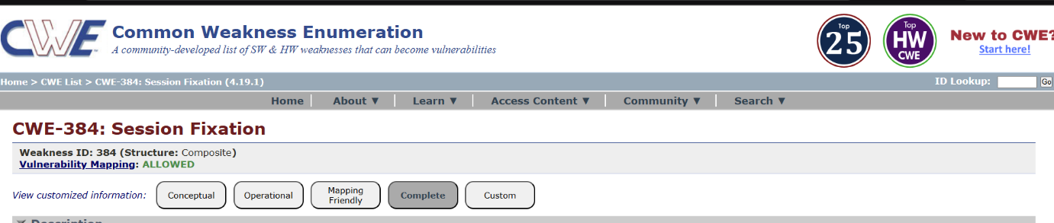

8. Vulnerability Name:- Untrusted Search Path
CWE/CVE :- CWE-426
OWASP/SANS Category:- A08:2025 Software or Data Integrity Failures
Description:- The product searches for critical resources using an externally-supplied search path that can point to resources that are not under the product's direct control.
Business Impact:- An untrusted search path vulnerability occurs when an application searches for executable files, libraries, or system resources in directories that can be modified by unauthorized users. Attackers may place malicious files in these directories, causing the application to execute the malicious code instead of the legitimate one.

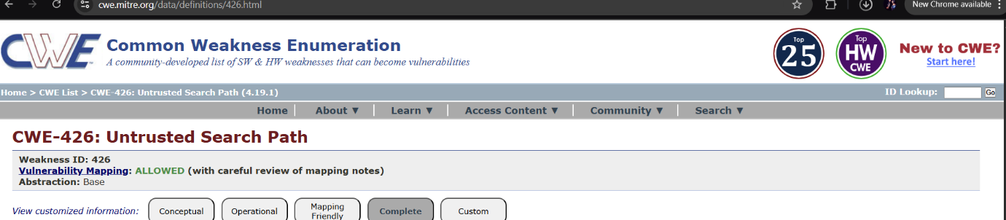

9.vulnerability name: Insufficient Logging
CWE/CVE :- CWE-778
OWASP/SANS Category:- A09:2025 Security Logging & Alerting Failures
Description:- When a security-critical event occurs, the product either does not record the event or omits important details about the event when logging it.
Business Impact:- Insufficient logging occurs when an application or system fails to properly record important events such as user activities, system errors, or security incidents. Without adequate logging, organizations may struggle to detect,investigate, and respond to security threats effectively.
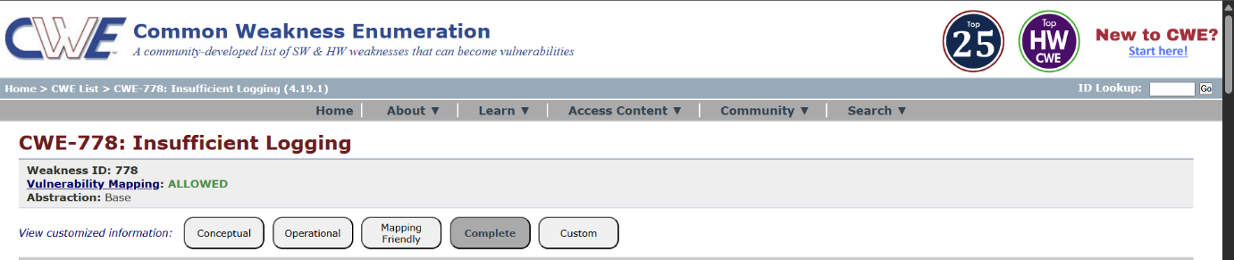
10. Vulnerability Name:- Divide By Zero
CWE/CVE :- CWE-369
OWASP/SANS Category:- A10:2025 Mishandling of Exceptional Conditions
Description:- The product divides a value by zero.
Business Impact:- A Divide by Zero vulnerability occurs when an application attempts to divide a number by zero during processing without proper error handling. This can cause application crashes, system instability, or unexpected behavior, potentially affecting business operations and service availability.

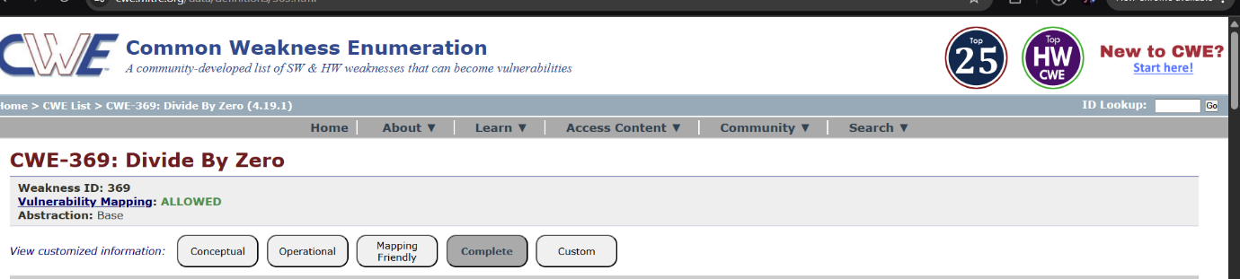

Stage-2
Title: Nessus scan
Overview :-
Nessus is one of the most widely used vulnerability scanning tools in cybersecurity. Developed by Tenable, Inc., Nessus helps organizations identify security weaknesses in computers, servers, networks, and applications before attackers can exploit them. It is commonly used by security professionals, penetration testers, and system administrators to improve system security.
Nessus is a widely used vulnerability scanning tool in the field of cybersecurity that helps organizations identify security weaknesses in their systems, networks, and applications. Developed by Tenable, Inc., Nessus is designed to detect vulnerabilities such as outdated software, missing security patches, weak configurations, and potential malware threats. It works by scanning target systems using a large collection of continuously updated plugins that test for known vulnerabilities.
During the scanning process, Nessus analyzes operating systems, network devices, databases, and web applications to identify security risks that could be exploited by attackers. The tool compares detected vulnerabilities with information from security databases such as the Common Vulnerabilities and Exposures, which is maintained with support from organizations like MITRE.
Nessus provides detailed reports that categorize vulnerabilities based on severity levels such as Low, Medium, High, and Critical, and it also suggests remediation steps to fix the issues. Security professionals, penetration testers, and system administrators commonly use Nessus to perform network scans, host scans, and compliance checks to ensure that systems follow security best practices. One of the key advantages of Nessus is its user-friendly interface and the ability to generate comprehensive reports that help organizations understand their security posture.
By regularly using Nessus to scan systems, organizations can proactively identify and fix vulnerabilities before they are exploited, thereby improving overall system reliability and reducing the risk of cyberattacks. Because of its powerful scanning capabilities, frequent plugin updates, and trusted reputation in the cybersecurity industry, Nessus remains one of the most popular vulnerability assessment tools used worldwide to strengthen IT security and protect critical infrastructure.
Nessus is a powerful and reliable vulnerability scanning tool that plays a key role in modern cybersecurity. By regularly scanning systems and identifying security weaknesses, organizations can protect their networks, reduce risks, and maintain a strong security infrastructure. Its ease of use, extensive vulnerability database, and detailed reporting make it one of the most popular tools for vulnerability management.
The main purpose of Nessus is to detect vulnerabilities, misconfigurations, and security risks in IT systems. It scans networks and systems to identify potential security flaws such as outdated software, weak passwords, missing patches, and configuration errors. By identifying these issues early, organizations can fix them and reduce the risk of cyberattacks.

List of Vulnerabilities :-
s.no | Vulnerability name | severity | plugins
1 | Service detection | INFO | 22964
2 | Apache tomcat detection | INFO | 39446
3 | Nessus SYN scanner | INFO | 11219
4 | OS identification failed | INFO | 50350
5 | OS identification detected | INFO | 209654

Report :-
1)Vulnerability Name : Service Detection
Severity : INFO
Plugin : 22964
Description : Service Detection is the process of identifying running services, open ports, and applications on systems within a network.
Solution : Disable services that are not required for business operations.
Business Impact : Attackers can identify vulnerable services and exploit them to gain unauthorized access.

2)Vulnerability Name : Apache Tomcat Detection
Severity : INFO
Plugin : 39446
Description : Apache Tomcat Detection indicates that a system is running the Apache Tomcat web server and that the service is publicly identifiable through network scanning or banner information.
Solution : Configure Tomcat to hide version details from HTTP headers to prevent information disclosure.
Business Impact : Attackers may exploit Tomcat vulnerabilities to gain unauthorized access to web applications or servers.

3)Vulnerability Name : Nessus SYN Scanner
Severity : INFO
Plugin : 11219
Description :Nessus SYN Scanner Detection indicates that the target system has responded to a SYN-based port scan performed by the vulnerability scanning tool Nessus, developed by Tenable.
Solution : Use monitoring systems such as Snort or Suricata to detect and alert on suspicious scanning activities.
Business Impact : Exposed services discovered during scans may contain vulnerabilities that attackers can exploit.

4)Vulnerability Name : OS Identification Failed
Severity : INFO
Plugin : 50350
Description : OS Identification Failed indicates that the vulnerability scanning tool was unable to accurately determine the operating system running on the target host during the scanning process.
Solution : Allow scanners to access necessary ports temporarily during authorized vulnerability assessments.
Business Impact : If the operating system cannot be identified, the scanner may miss OS-specific vulnerabilities.

5)Vulnerability Name : OS FingerPrints Detected
Severity : INFO
Plugin : 209654
Description : detecting OS fingerprints is commonly used during vulnerability assessments.
Solution : Limit exposure of critical systems by placing them in restricted network segments.
Business Impact : Security breaches caused by successful attacks may result in financial losses.

Stage – 3
Title: Design and apply context-aware access controls based on user identity, device posture, location, and application risk.
Context-aware access control is an advanced security approach used in Zero Trust architecture to protect enterprise applications. Instead of allowing access based only on usernames and passwords, this model evaluates multiple contextual factors such as user identity, device posture, location, and application risk before granting access.
With modern workplaces using cloud services, remote work, and personal devices, traditional security methods are no longer sufficient. Context-aware controls create a dynamic security system that analyzes each access request in real time and decides whether to allow, block, limit, or challenge the request. This ensures that only trusted users with secure devices and safe conditions can access sensitive resources.
Working of Context-Aware Access Control
The system works by collecting different contextual signals whenever a user attempts to access an application. These signals are processed by a policy engine integrated with security tools such as identity providers, endpoint security platforms, and network monitoring systems.
- The user attempts to access an application through a secure access broker like Zscaler Private Access (ZPA).
- The system verifies the user’s identity using an Identity Provider such as Azure Active Directory or Okta with multi-factor authentication (MFA).
- The device posture is checked to confirm whether the endpoint meets security requirements such as updated antivirus, disk encryption, and operating system patches.
- The system evaluates the user’s location and network environment to determine whether the access request originates from a trusted or suspicious source.
- The application’s risk level is analyzed to determine the level of security required. Based on all these factors, the policy engine decides whether to grant access, deny access, or require additional authentication.
Identification of Context Factors
Context-aware access control identifies several key factors before granting access:
User Identity
User identity is verified through an Identity Provider. Attributes such as user role, department, and group membership are checked to determine whether the user is authorized to access a specific application.
Device Posture
The system evaluates the security health of the device. This includes checking whether the device has active antivirus software, disk encryption enabled, updated operating system patches, and no suspicious activity detected by endpoint security tools.
Location and Network Environment
The system examines the user’s geographical location and network connection. Access requests from trusted networks or known locations are considered lower risk, while requests from unfamiliar countries or public Wi-Fi networks may trigger stricter security measures.
Application Risk
Applications are categorized based on their importance and sensitivity. High-risk applications such as financial systems, customer databases, or source code repositories require stricter access policies compared to low-risk applications like internal documentation portals.
Policy Implementation
Organizations implement context-aware access policies using conditional rules. These rules combine different contextual signals to determine access decisions.
Example policies include:
- Allow access if the user belongs to a specific group and the device is compliant.
- Require step-up authentication if access is requested from a remote or unfamiliar location.
- Restrict access to business hours or trusted networks for critical applications.
- These policies ensure that security controls adapt dynamically based on the situation.
Context-aware access control strengthens enterprise security by evaluating multiple contextual factors before granting access. By combining user identity, device posture, location, and application risk, organizations can build a flexible and intelligent security framework.
This approach aligns with the Zero Trust principle of “never trust, always verify,” ensuring that access decisions are based on real-time risk evaluation rather than static security rules.

Conclusion:
Stage 1: In conclusion, web application testing is a crucial process that ensures the security, functionality, and reliability of web-based software. It involves a comprehensive evaluation of various aspects, including user interface, functionality, performance, and security to identify and rectify issues before they impact end-users. This process not only enhances the quality of web applications but also bolsters their resilience against potential threats and vulnerabilities. In an age where online services and applications are integral to our daily lives, effective web application testing is essential to deliver a seamless and secure user experience.
Stage 2: The Nessus report for the specific website has highlighted key security insights. It identified vulnerabilities, categorized by severity, with a focus on critical and high-risk issues that need immediate attention. Recommendations for addressing these vulnerabilities include patching, reconfiguration, and other security measures, with a priority on actions that can have the most significant impact. Compliance with industry standards and best practices is considered, ensuring alignment with recognized security benchmarks like OWASP guidelines. The report underscores the need for continuous monitoring, regular updates, and ongoing security efforts to maintain a strong security posture. In summary, the Nessus report offers a clear view of the website's security state, provides guidance on mitigating vulnerabilities, and stresses the importance of sustained vigilance against evolving threats.
Stage 3: The implementation of Zscaler Private Access marks a pivotal shift from a vulnerable, network-centric security model to a resilient, identity-centric Zero Trust architecture. By enforcing least-privilege access and rendering private applications invisible to the internet, this project effectively neutralizes the threats of lateral movement and network-based attacks. The solution not only fortifies the organization's security posture against modern cyber threats but also delivers a seamless and high-performance experience for a distributed workforce. Furthermore, the decoupling of access from the network simplifies IT operations, reduces dependency on legacy VPN infrastructure, and provides granular visibility into user-application interactions. Ultimately, this initiative establishes a future-ready foundation for secure digital transformation..

Future Scope:
Stage 1: future scope of web application testing
The future scope of web application testing is promising and evolving rapidly, driven by the continuous growth of the internet and web-based applications. Here are some key aspects of its future scope:
▪ Increased Demand: As more businesses and services move online, the demand for web applications continues to grow. This, in turn, increases the demand for web application testing to ensure security, reliability, and functionality.
▪ Advanced Technologies: The complexity of web applications is rising with the integration of advanced technologies like AI, IoT, and blockchain. Testing these cutting-edge applications will require specialized skills and tools.
▪ Security Emphasis: With the growing number of cyber threats and data breaches, security testing for web applications will become even more critical. Testers will need to focus on vulnerabilities, data protection, and compliance with regulations like GDPR.
▪ Mobile and Cross-Browser Testing: Mobile usage is on the rise, and web applications must be responsive and functional on various devices and browsers. Testing for cross-compatibility will be essential.
▪ Performance Testing: As user expectations for speed and performance increase, load testing, stress testing, and other performance testing types will be crucial to ensure web applications can handle traffic spikes.
Stage 2: future scope of the testing process you understood.
The future scope of the web application testing process, particularly in terms of identifying vulnerabilities, is exceedingly promising due to the continuous growth of digital platforms, the escalating importance of cybersecurity, and the ever-evolving threat landscape. Here are some key aspects that highlight the prospective scope of web application testing for vulnerability discovery:
▪ AI-Driven Testing: The integration of artificial intelligence (AI) and machine learning (ML) into web application testing tools will revolutionize the way vulnerabilities are identified. AI algorithms can swiftly scan vast amounts of code and data to pinpoint vulnerabilities that might elude human testers.
▪ IoT and Mobile App Testing: With the proliferation of Internet of Things (IoT) devices and the increasing usage of mobile applications, the scope of web application testing will extend to encompass these areas. Ensuring the security of IoT devices and the interfaces they use will become critical.
▪ Blockchain and Cryptocurrency Security: As blockchain technology and cryptocurrencies continue to gain traction, security testing will be imperative to safeguard transactions and digital assets. Ensuring the robustness of blockchain-based applications will be a specialized
niche in web application testing. Serverless Architectures: With the adoption of serverless computing, web application testing will need to adapt to assess the security of serverless functions and APIs. Ensuring that serverless components are free from vulnerabilities will be paramount.
▪ Container Security: As containerization technologies like Docker and Kubernetes become ubiquitous, web application testing will extend to cover container security. This includes ensuring that container images and orchestration configurations are free from vulnerabilities.
Stage 3: future scope of Aware Access Control
The successful deployment of ZPA lays the groundwork for a broader, more integrated security ecosystem. Future enhancements can be explored to further mature the organization's security capabilities:
▪ Integration with Zscaler Internet Access (ZIA): Converging Private Access (ZPA) with Internet Access (ZIA) to create a unified Secure Access Service Edge (SASE) platform, managing all web and private traffic through a single policy framework.
▪ Advanced Device Posture Checking: Moving beyond basic compliance to incorporate real-time risk scores from EDR tools, blocking access if a device shows signs of active compromise.
▪ Privileged Remote Access: Extending ZPA to third-party vendors and contractors with time-bound, audited access to specific critical systems, replacing jump boxes and bastion hosts.
▪ IoT/OT Segmentation: Applying the same micro-tunneling principles to Internet of Things (IoT) and Operational Technology (OT) devices to ensure they can only communicate with specific management servers.
▪ AI-Driven Anomaly Detection: Leveraging machine learning on ZPA logs to detect behavioral anomalies, such as a user accessing an application at an unusual hour or from a strange location, triggering automated MFA challenges or access revocation.
▪ Cloud Workload Protection: Utilizing ZPA to secure connections between containers and microservices in multi-cloud environments (AWS, Azure, GCP), ensuring east-west traffic between workloads is encrypted and authenticated.
▪ Automated Provisioning/Deprovisioning: Enhancing the identity provider integration to automatically revoke application access the moment an employee is terminated or changes roles, ensuring near real-time access control.
▪ Digital Experience Monitoring (DEM): Implementing DEM tools to proactively monitor the end-user experience, identifying network latency or application performance issues before they impact productivity.

THANK YOU

